training 1 epoch...

16.332611560821533 seconds used......

1 training finished! average train loss: 0.9909798045243535

evaluating...

Confusion matrix, without normalization

[[ 40 3 2]

[ 78 88 20]

[ 72 68 214]]

Normalized confusion matrix

[[0.88888889 0.06666667 0.04444444]

[0.41935484 0.47311828 0.10752688]

[0.20338983 0.1920904 0.60451977]]

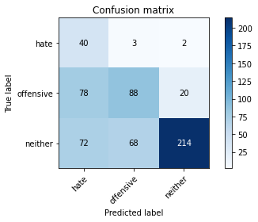

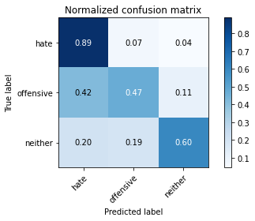

precision recall f1-score support

hate 0.21 0.89 0.34 45

offensive 0.55 0.47 0.51 186

neither 0.91 0.60 0.73 354

accuracy 0.58 585

macro avg 0.56 0.66 0.53 585

weighted avg 0.74 0.58 0.63 585

average eval_loss: 0.869707586367925, accuracy: 0.5846153846153846

training 2 epoch...

16.382876873016357 seconds used......

2 training finished! average train loss: 0.6948670840689114

evaluating...

Confusion matrix, without normalization

[[ 39 6 0]

[ 55 112 19]

[ 56 95 203]]

Normalized confusion matrix

[[0.86666667 0.13333333 0. ]

[0.29569892 0.60215054 0.10215054]

[0.15819209 0.26836158 0.57344633]]

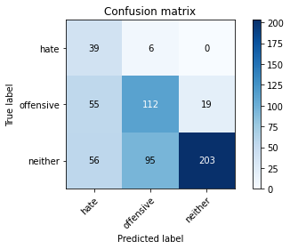

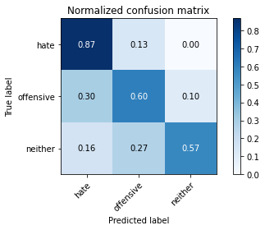

precision recall f1-score support

hate 0.26 0.87 0.40 45

offensive 0.53 0.60 0.56 186

neither 0.91 0.57 0.70 354

accuracy 0.61 585

macro avg 0.57 0.68 0.56 585

weighted avg 0.74 0.61 0.64 585

average eval_loss: 0.9023111025492351, accuracy: 0.6051282051282051

training 3 epoch...

16.57230496406555 seconds used......

3 training finished! average train loss: 0.3816948865673372

evaluating...

Confusion matrix, without normalization

[[ 30 10 5]

[ 10 156 20]

[ 13 83 258]]

Normalized confusion matrix

[[0.66666667 0.22222222 0.11111111]

[0.05376344 0.83870968 0.10752688]

[0.03672316 0.23446328 0.72881356]]

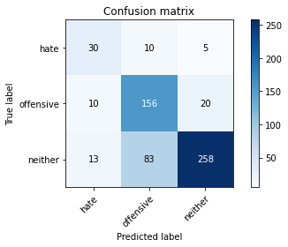

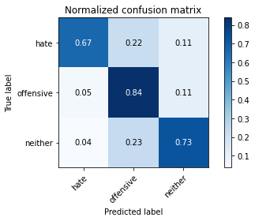

precision recall f1-score support

hate 0.57 0.67 0.61 45

offensive 0.63 0.84 0.72 186

neither 0.91 0.73 0.81 354

accuracy 0.76 585

macro avg 0.70 0.74 0.71 585

weighted avg 0.79 0.76 0.77 585

average eval_loss: 0.6668927659591039, accuracy: 0.7589743589743589

training 4 epoch...

16.73556137084961 seconds used......

4 training finished! average train loss: 0.14077987521886826

evaluating...

Confusion matrix, without normalization

[[ 34 9 2]

[ 17 153 16]

[ 22 101 231]]

Normalized confusion matrix

[[0.75555556 0.2 0.04444444]

[0.09139785 0.82258065 0.08602151]

[0.06214689 0.28531073 0.65254237]]

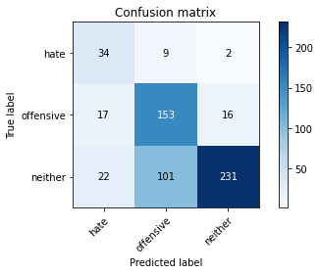

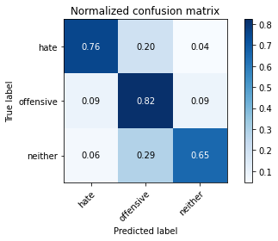

precision recall f1-score support

hate 0.47 0.76 0.58 45

offensive 0.58 0.82 0.68 186

neither 0.93 0.65 0.77 354

accuracy 0.71 585

macro avg 0.66 0.74 0.67 585

weighted avg 0.78 0.71 0.72 585

average eval_loss: 1.0753833591938018, accuracy: 0.7145299145299145

training 5 epoch...

16.91794991493225 seconds used......

5 training finished! average train loss: 0.06965706567279994

evaluating...

Confusion matrix, without normalization

[[ 36 7 2]

[ 25 144 17]

[ 22 87 245]]

Normalized confusion matrix

[[0.8 0.15555556 0.04444444]

[0.1344086 0.77419355 0.09139785]

[0.06214689 0.24576271 0.6920904 ]]

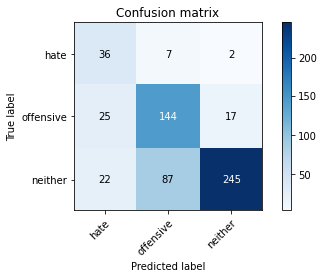

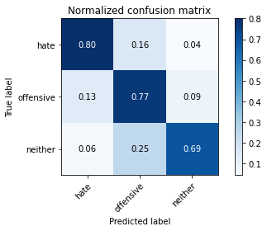

precision recall f1-score support

hate 0.43 0.80 0.56 45

offensive 0.61 0.77 0.68 186

neither 0.93 0.69 0.79 354

accuracy 0.73 585

macro avg 0.66 0.76 0.68 585

weighted avg 0.79 0.73 0.74 585

average eval_loss: 1.0625060545901457, accuracy: 0.7264957264957265

model of 1 epoch

Confusion matrix, without normalization

[[ 48 1 2]

[ 64 76 29]

[ 81 61 223]]

Normalized confusion matrix

[[0.94117647 0.01960784 0.03921569]

[0.37869822 0.44970414 0.17159763]

[0.22191781 0.16712329 0.6109589 ]]

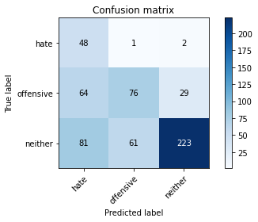

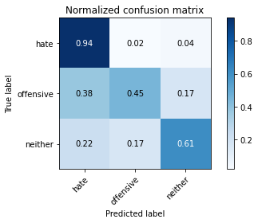

precision recall f1-score support

hate 0.25 0.94 0.39 51

offensive 0.55 0.45 0.50 169

neither 0.88 0.61 0.72 365

accuracy 0.59 585

macro avg 0.56 0.67 0.54 585

weighted avg 0.73 0.59 0.63 585

average eval_loss: 0.8924717525641124, accuracy: 0.5931623931623932

0.5931623931623932